Logical Consistency Evaluation of the Heart Disease Ontology Using the HermiT Reasoner
The logical consistency and class satisfiability of the Heart Disease Ontology (HDO) was tested using the HermiT reasoner (version 1.4.3.456) in Protégé 5.6.9. The reasoner managed to classify the ontology and a Description Logic (DL) query against owl:Nothing did not produce any unsatisfiable named classes. The results confirmed the logical consistency and coherence of the ontology.
HermiT Reasoner Execution:
The Heart Disease Ontology (HDO) was tested with the HermiT reasoner (version 1.4.3.456) in Protégé 5.6.9. The reasoner was able to classify the ontology and infer the class hierarchy without reporting any inconsistencies as shown in Figure 1. The successful reasoning process and lack of inconsistency warnings are used as evidence for the logical coherence of the ontology.
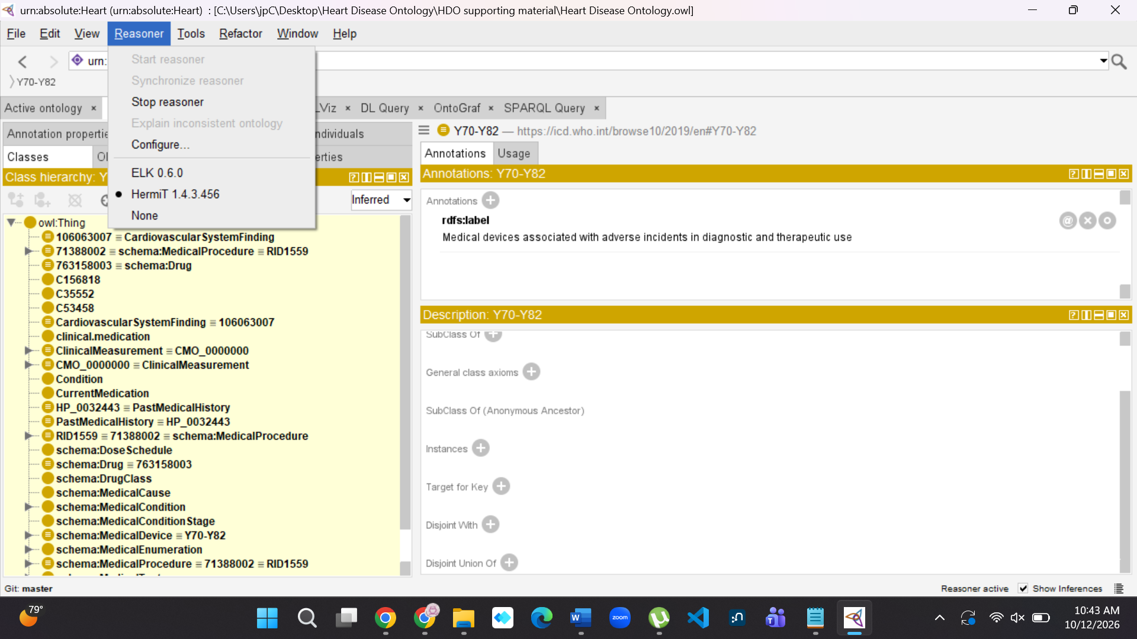
Figure 1 HermiT Reasoner Execution
Class Satisfiability Verification Using DL Query
The Description Logic (DL) Query facility of Protégé with the HermiT reasoner was used to assess class satisfiability. The query owl:Nothing was used to look for potentially unsatisfiable classes in the Heart Disease Ontology (HDO) as shown in Figure 2. No unsatisfiable named classes were detected, as the result was zero subclasses (0 of 0). This is another evidence of the logical coherence and consistency of the ontology.
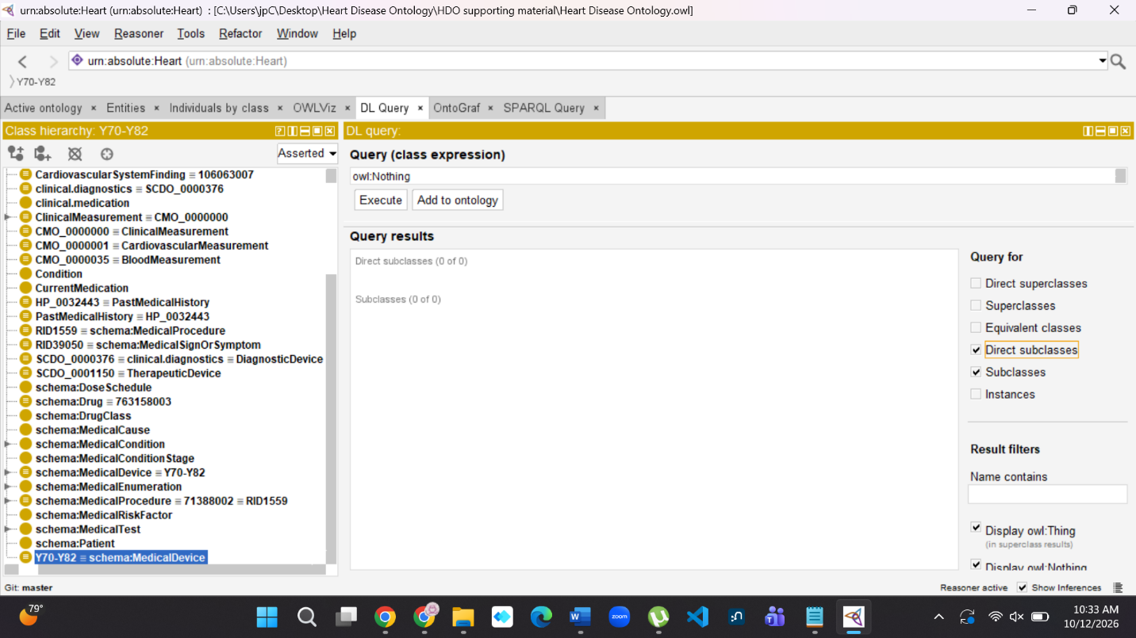
Figure 2 DL Query

